Control unit is combinational circuit.

Only input of control unit is opcode.

RTL: R-Type Instructions

Instruction Fetch Unit at the Beginning of Add

The Single Cycle Datapath During Add

Firstly, we will design ALU control which is responsible to send the right select signal to ALU.

Instruction Fetch Unit at the End of Add

The Single Cycle Datapath During Load

The Single Cycle Datapath During Store

The Single Cycle Datapath During Branch

Instruction Fetch Unit at the End of Branch

**STEP 4: GIVEN DATAPATH RTL 🡪 CONTROL**

ALUop (which comes from control unit) is 10 so that ALU control will understand that the instruction is an R-type instruction so ALU control must check the function field which comes as an input.

RegWr is 0 so MemtoReg is not important (X).

Truth Table for ALUControl

8 bit input for ALU Control, we cant design output bits by Karnaugh Map.

Inputlara göre bakıyoruz. Örneğin C0 sadece en alt 2 satırda 1. En alt 2 satırı diğerlerinden ayıran özelliklere bakıyoruz.

c1’ = p1f2 ----> c1 = p1’ + f2’

The ALU Control Block

The “Truth Table” for the Main Control

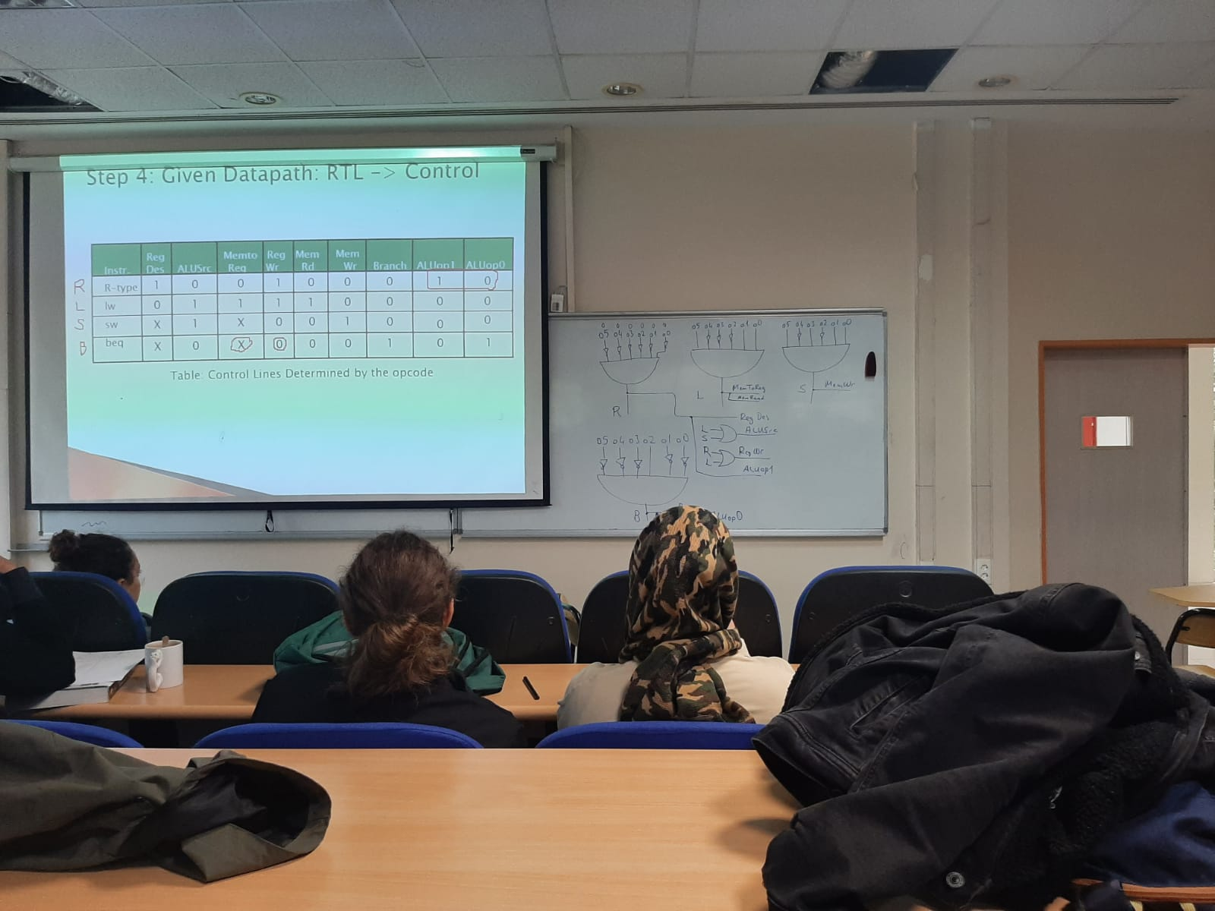



Implementation of the Main Control

An abstract view of the critical path – load instruction

Dfetch + Dreg-read + Dmux + Dalu + Dmux = D (R-type) 🡪 50 ns diyelim CLK >= 50ns  
Dfetch + Dreg-read + Dalu + Dmem-read + Dmux = D (lw) 🡪 100ns diyelim CLK >= 100ns

Cycle period 100ns olmalı (slowest).